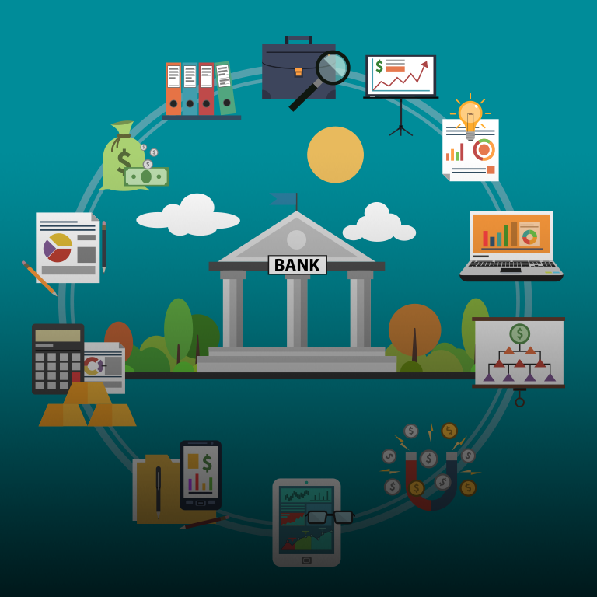

Banking System Design

CEBE | Birmingham City University| Computer Science

designing of a Python banking system

By Dharmarlou bowen

Year 1

Contents

Design of Banking System 2

References 3

**INTRODUCTION |** This document will track the development, testing and implementation of prototype banking system program. There is a variety of services that utilise banking systems in some shape or form, but at the core of each system is essential attributes that end users should be able to use. The prototype that is being design will focus on the basic operations of such a system.

These core operations being depositing, withdrawing and transferring money as well as providing users the ability take out loans. Additionally, there will also be features implemented for admin usage. The admin will be able to create, search, view/update and close customer accounts.

# Designing of Banking System

The design of the banking system will be the first process to occur. Flow charts will be used to depict the steps and relationships between the data being passed through the login process as well as other critical elements of the program. The first flowchart below depicts the login process while the other covers elements such as money transferring between bank accounts.

Flowchart 0 (**Overview**)

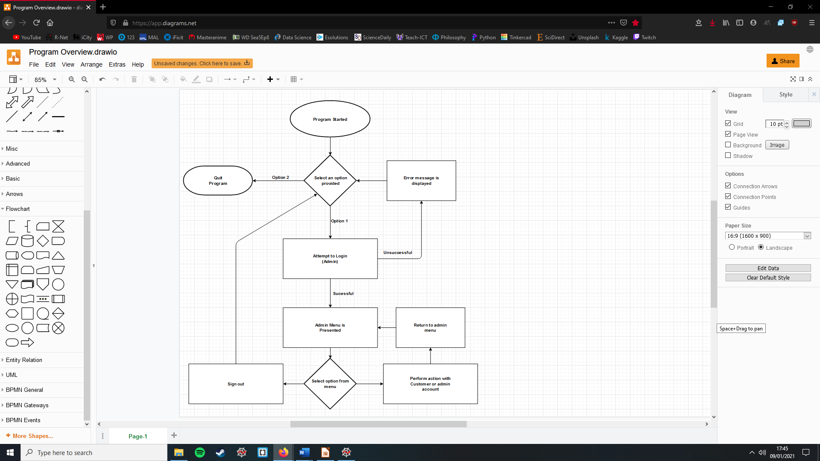

***(Program Overview, Figure 1.0)***

Flowchart 1 (**Log-in Process**)

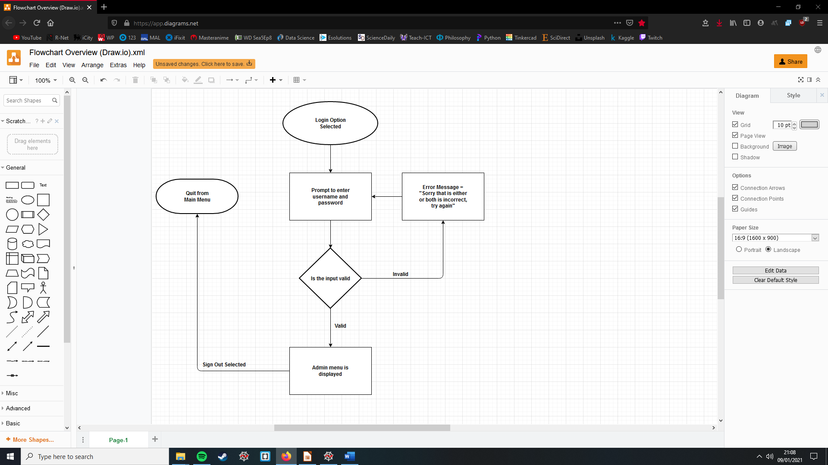

***(Program Log-in Process, Figure 2.0)***

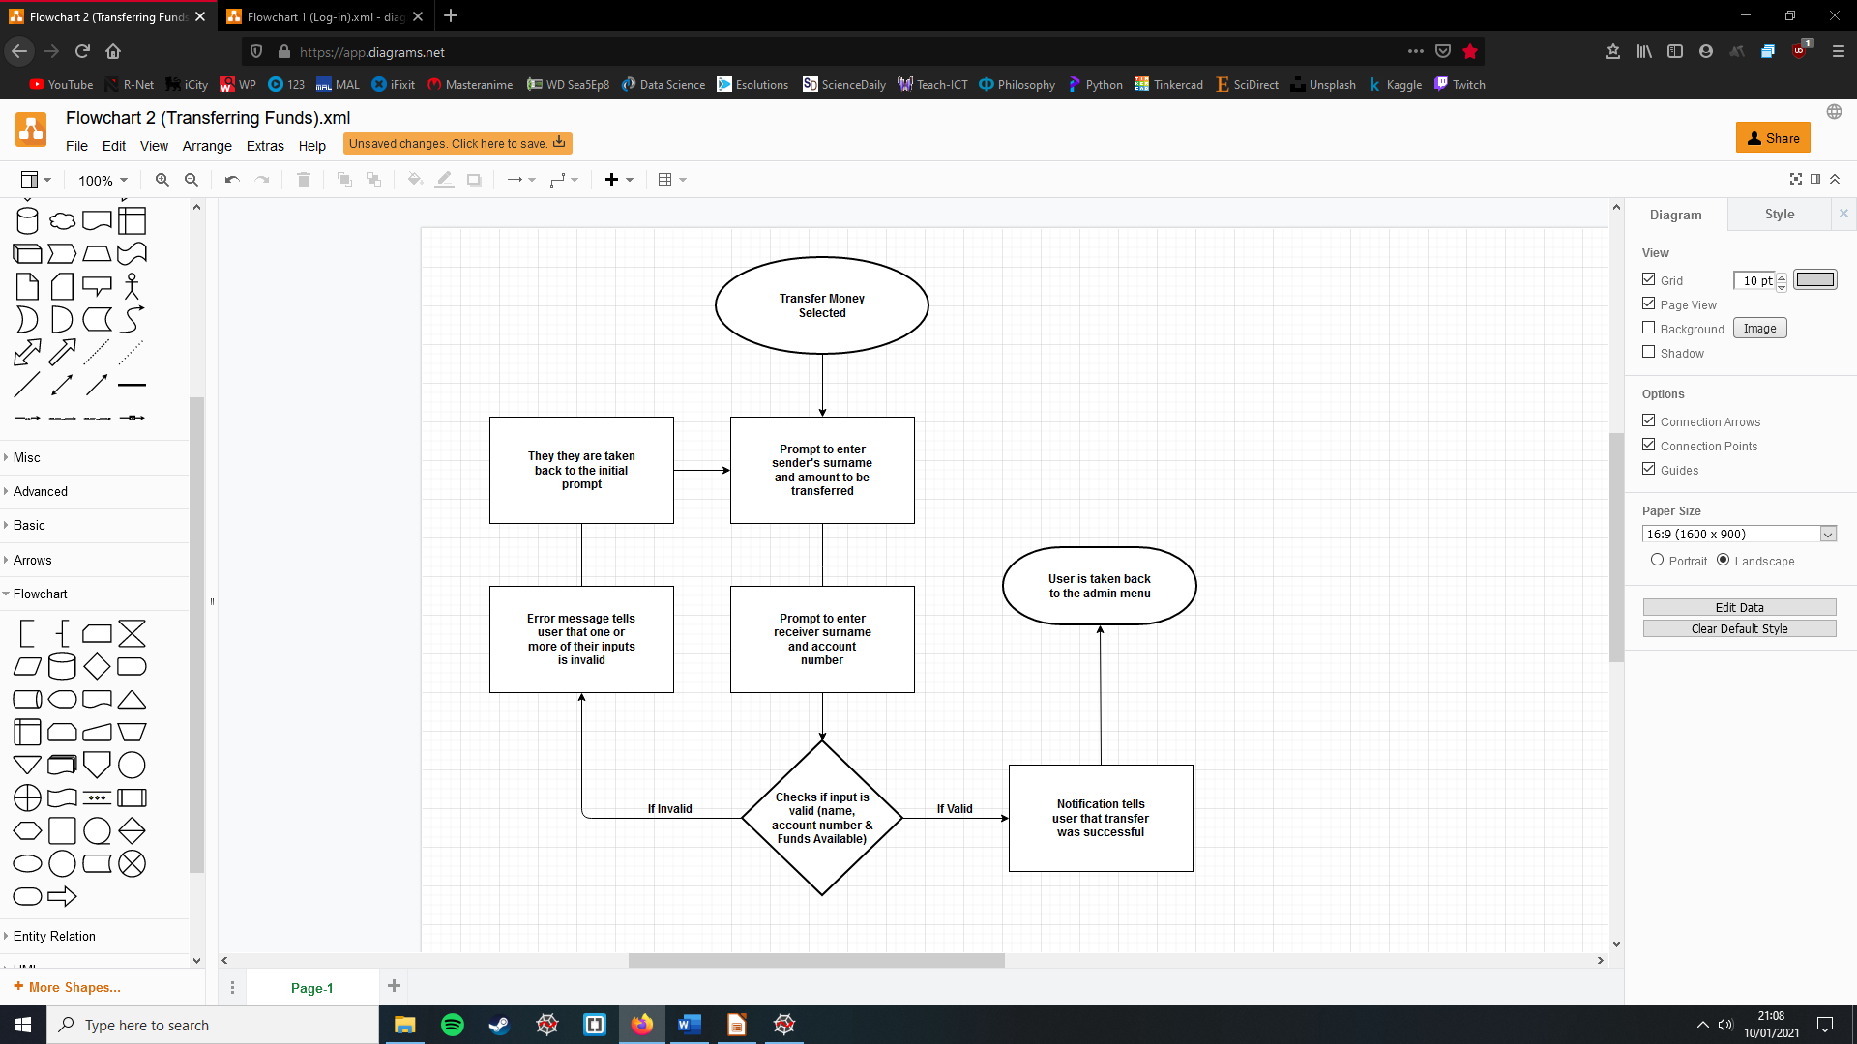Flowchart 2 (**Transferring of Funds**)

***(Program transfer funds Process, Figure 3.0)***

# References

[1] Image used cover page, <https://www.bcsconsulting.com/blog/core-banking-systems-hint-at-why-banks-find-agile-a-challenge/>

[2] Figures 1.0,2.0 & 3.0, Flowchart Diagram made with Draw.io, <https://app.diagrams.net/>